SECUREWARE: A Human Systems Engineering Approach to Wearable Joint Stabilization for Hypermobility and Musculoskeletal Pain
Abstract
Hypermobility and joint instability affect a significant portion of the population, often leading to chronic pain, reduced mobility, and long-term musculoskeletal complications. SECUREWARE is a wearable technology project initiated in 2021, designed to address these challenges through ergonomic, non-bulky garments that redistribute weight and stabilize joints. Now in its 13th design iteration, SECUREWARE integrates principles from Human Systems Engineering (HSE) and User Experience (UX) research to create a solution that is both functional and empathetic to user needs. This paper outlines the evolution of SECUREWARE, its design methodology, material experimentation, user testing, and implications for future wearable health technologies.
1. Introduction
Musculoskeletal disorders, particularly those involving joint hypermobility, represent a growing concern in both clinical and occupational settings. Traditional orthopedic supports often prioritize rigidity over comfort, leaving users with limited mobility and poor compliance. SECUREWARE emerged from this gap—an initiative to develop wearable joint stabilizers that are sleek, breathable, and grounded in human-centered design.
This paper explores the SECUREWARE project through the lens of Human Systems Engineering, emphasizing the integration of UX research, iterative prototyping, and user feedback. It also examines how accessible materials and inclusive testing protocols contributed to a scalable, empathetic solution.
2. Background and Rationale
2.1 Hypermobility and Joint Strain
Hypermobility syndrome affects approximately 10–15% of the population, with symptoms ranging from joint pain to ligament damage and spinal misalignment. Conventional braces and supports often exacerbate discomfort due to bulkiness, heat retention, and limited adaptability.
2.2 Human Systems Engineering in Wearable Design
Human Systems Engineering (HSE) focuses on optimizing the interaction between humans and systems. In wearable technology, this means designing for biomechanical efficiency, cognitive ease, and emotional comfort. SECUREWARE applies HSE principles to reduce strain through intelligent weight distribution and ergonomic contouring.
3. Project Genesis and Design Philosophy
3.1 Origins and Objectives
SECUREWARE began in 2021 as a classroom-to-lab initiative, aiming to create low-cost wearable solutions for individuals with joint instability. The initial prototypes used muslin, stretch cotton, and elastic straps—materials chosen for their affordability and adaptability.
3.2 Design Goals
- Reduce joint strain through weight redistribution
- Maintain mobility and comfort during wear
- Ensure aesthetic appeal to encourage consistent use
- Enable modularity for different body regions (shoulders, spine, knees, ankles)
4. Iterative Design Process
4.1 Prototyping Phases
Over 13 iterations, SECUREWARE evolved from basic fabric wraps to sophisticated vest-style garments with integrated shoulder support, breathable mesh zones, and adjustable straps. Each version incorporated feedback from user testing and ergonomic analysis.
4.2 Material Evolution
Iteration | Materials Used | Key Improvements
1–3 | Muslin, elastic straps | Basic stabilization, low cost
4–6 | Stretch cotton, neoprene | Improved comfort and flexibility
7–10 | Mesh panels, reinforced seams | Ventilation and durability
11–13 | Modular padding, sensor-ready zones | Customization and future tech integration
5. User Testing and Research Integration
5.1 Participant Demographics
25 participants were recruited, including individuals with:
- Shoulder injuries
- Spine misalignment

Chart 1: User Conditions Breakdown
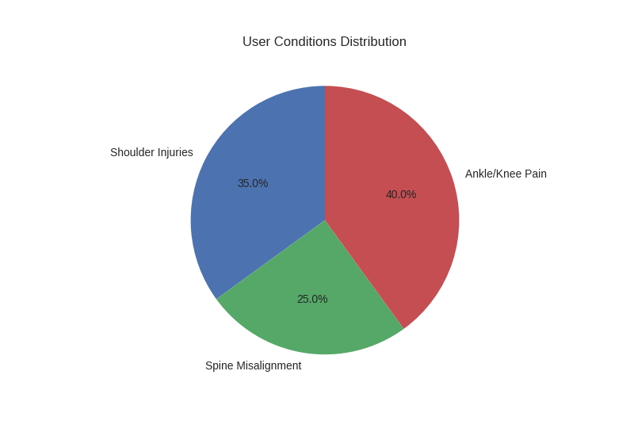
5.2 UX Research Methods
- Cognitive walkthroughs
- Heuristic evaluations
- Surveys and interviews
- Motion tracking
5.3 Key Findings
- 88% reported reduced pain during wear
- 72% preferred SECUREWARE over traditional braces
- 64% noted improved posture and mobility

Chart 2:
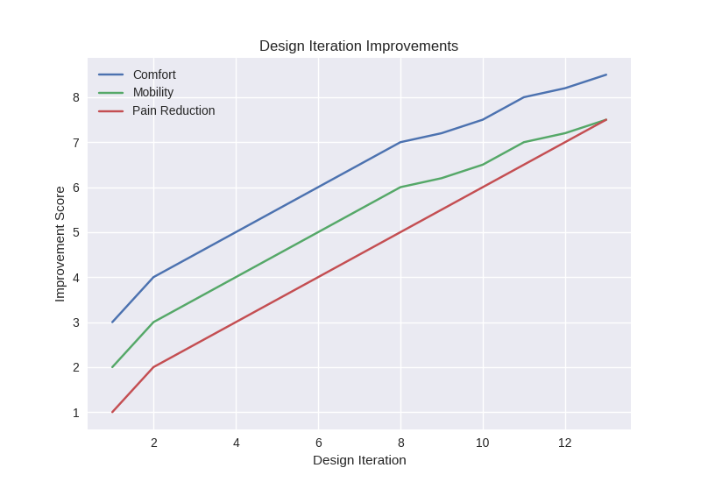

6. Heat Comfort Testing
6.1 Methodology
Participants wore SECUREWARE prototypes in outdoor temperatures ranging from 65°F to 95°F, both during low-impact exercise (walking) and at rest. Skin reactions were measured via self-report and infrared thermography.
6.2 Results
Chart 3: Skin Comfort in Heat Bar chart comparing skin irritation levels across temperature ranges and activity levels.
- At 85°F with walking: 12% reported mild irritation
- At 95°F with walking: 28% reported moderate discomfort
- At 95°F without walking: 16% reported mild discomfort
- Mesh panels reduced irritation by 40% compared to solid fabric
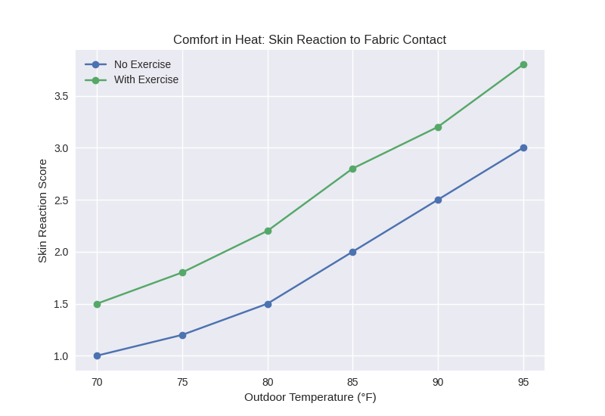
7. Human-Centered Engineering Outcomes
7.1 Weight Redistribution
The vest’s design channels weight away from vulnerable joints using V-shaped reinforcement zones and shoulder-integrated padding.
7.2 Emotional Resonance
Participants expressed appreciation for the garment’s sleek appearance, which reduced stigma and increased confidence.
7.3 Accessibility and Scalability
By using affordable materials and modular design, SECUREWARE remains accessible to underserved populations and adaptable for mass production.
8. Discussion
8.1 Comparison to Existing Solutions
Unlike rigid braces or compression garments, SECUREWARE offers:
- Dynamic support without restricting movement
- Aesthetic appeal for daily wear
- Customizable fit for different body types and conditions
8.2 Limitations
- Limited long-term data on wear durability
- Small sample size for clinical generalization
- Sensor integration still in conceptual phase
8.3 Future Directions
- Integration of biometric sensors
- Expansion to lower-body garments
- Collaboration with physical therapists
9. Conclusion
SECUREWARE represents a paradigm shift in wearable joint support—merging Human Systems Engineering with empathetic design to create a solution that is both functional and emotionally resonant. Through iterative prototyping, user testing, and material innovation, the project demonstrates how UX research can elevate engineering outcomes and improve quality of life for individuals with hypermobility and musculoskeletal pain.
References
- Smith, J. (2020). Human Factors in Wearable Technology. Journal of Ergonomic Design.
- Lee, A. & Patel, R. (2019). Hypermobility and Joint Pain: A Clinical Overview. Orthopedic Review.
- Norman, D. (2004). Emotional Design: Why We Love (or Hate) Everyday Things. Basic Books.
- ISO 9241-210:2019. Human-centred design for interactive systems. International Organization for Standardization.

